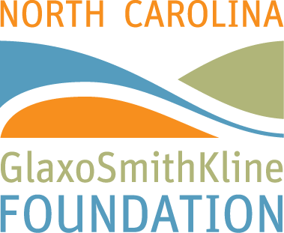

North Carolina GlaxoSmithKline Women in Science Scholars Program
Spring Conference Highlights

Friday, March 27, 2015

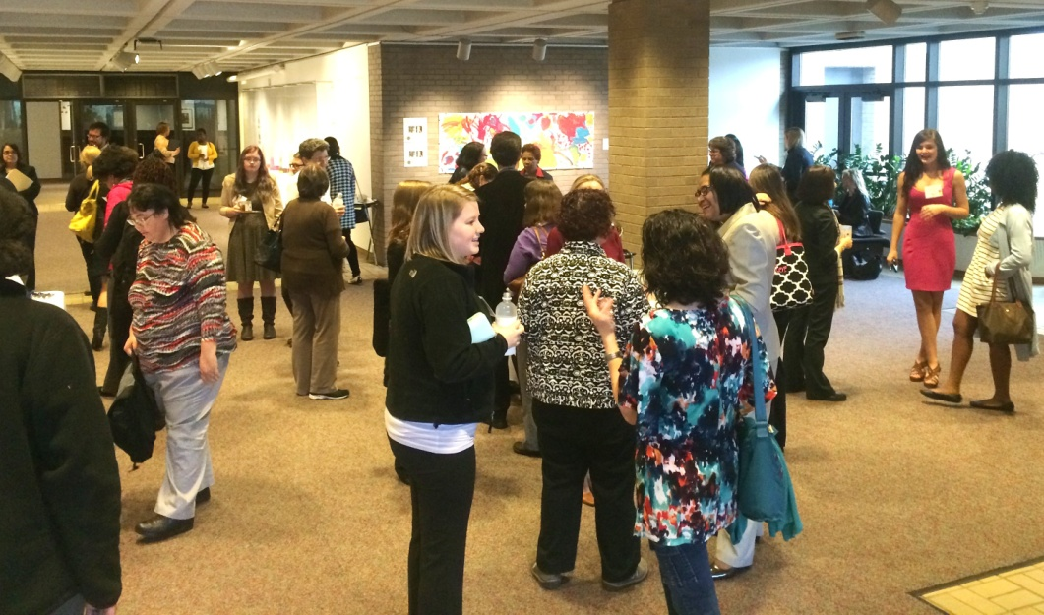

Kristin Smith, Project Director for the Big Picture Enrichment Program at the North Carolina Museum of Art, welcomed the North Carolina GlaxoSmithKline Foundation Women in Science Scholars Spring Conference guests, which was held at the NC Museum of Art on Blue Ridge Road in Raleigh. She explained how the world of art can help people make connections with the past and with their own lives, and how art intersects with science and encourages collaboration, problem solving and critical thinking.

Marilyn Foote-Hudson, Executive Director of the North Carolina GlaxoSmithKline Foundation welcomed the guests and announced that the Foundation’s Board of Directors has decided to honor volunteer GSK mentors by placing $10,000 in endowments at each university that currently has established endowments with the North Carolina GlaxoSmithKline Women in Science Scholars Program. (All eligible universities will be contacted by the Foundation for guidelines and requirements later in the year.)

She also reported highlights of the North Carolina GlaxoSmithKline Foundation’s achievements in 2014, noting that the Foundation made new grant commitments totaling $2.6 million to advance science, health and education, bringing the total grants approved to nearly $65 million. Some milestones reached in 2014 included awarding the 100th Ribbon of Hope grant, and celebrating the 20th anniversary of the Child Health Recognition Awards program. She thanked the students and faculty in attendance, and recognized them for their roles in making the Women in Science Scholars program so successful over the past 20 years.

“The Intersection of Art and Science” presented by Noelle Ocon, Associate Conservator of paintings at the Museum, explained her job of examining, documenting and conserving the 17th-century Dutch and Flemish collection. She said that cleaning paintings involves a great deal of science and applied mathematics. Use of technology such as infrared reflectography, x-radiography, gamma radiography, spectroscopy, microscopy and digital imaging allows conservators to make records of their restoration projects and also adds to the historic accuracy around a painting or sculpture and an artist, enriching the areas of research and art education.

The Iris catered a great lunch in the Blue Ridge Atrium, and after lunch, attendees were divided into groups and visited areas to learn more about the relationship between art and science.

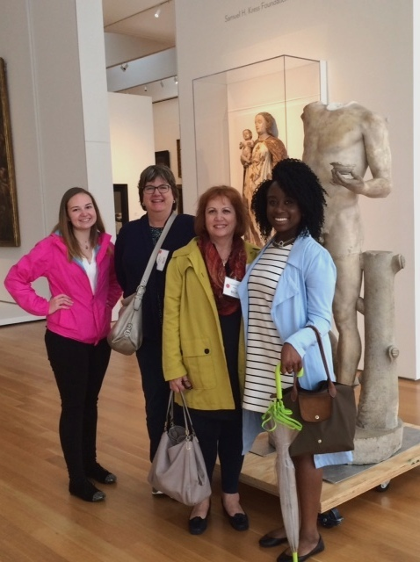
STEM in Arts, led by Kristin Smith, focused on how we might apply ways of thinking about art to our thinking in science. Using “Spring on the Missouri” (1945) by Thomas Hart Benton, she asked a series of questions that challenged viewers to observe closely to help tell a story, analyze the painting and critically think about it by supporting ideas with evidence. She said this visual thinking strategy is an effective tool in the classroom and the work place, because it creates an environment that brings fresh perspectives. She also led a hands-on exercise in which participants used simple shapes to create increasingly complex pictures. By having participants approach problems as an artist might she asked participants to think about the same skills might be used in science.

Forces of Nature facilitated by docents highlighted how artists capture the forces of nature in works of art. The afternoon sessions included the option for tours on your own.

Marilyn Foote-Hudson stated that although the current Women in Science Program model may need to be modified, the Board of Directors and staff are committed to the program’s continued success. She welcomed suggestions from the mentors, scholars and faculty.

Save the date! The Women in Science Scholars Annual Meeting will be held on Monday, October 5, 2015. Details will be sent closer to the date.

