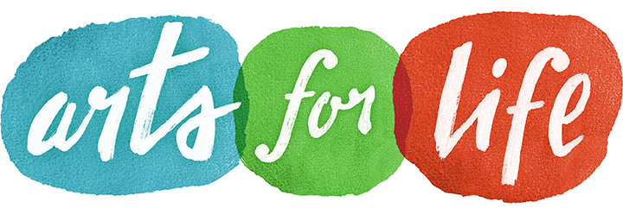

FOR IMMEDIATE RELEASE
Contact: Rachel Zink
Executive Director, Arts For Life
828-772-5339

Arts For Life Clinic Art Tables - Advance Health for Durham County Residents

May 2, 2016 - Durham, NC - The North Carolina GlaxoSmithKline Foundation recently awarded Arts For Life a Ribbon of Hope grant to expand educational art programs to pediatric patients with serious and chronic illnesses at Duke Children’s Hospital and Health Center.

With the expansion of the Arts For Life clinic art table program to the 2nd, 3rd, and 4th floor clinics of Duke Children’s Hospital, pediatric patients and family members can count on educational and engaging art lessons in waiting rooms while they wait for and receive treatments, procedures, appointments, and test results. The expansion will work to decrease stress levels and improve the healthcare experience for children and families.

Nurse Manager Kristen Ammon says, “Here at Duke Children’s Hospital and Health Center, it is our ultimate goal to provide the best patient and family experience, in spite of the challenges that acute and chronic illnesses present. Arts For Life is absolutely central to that mission, and through this expansion, will only continue to make lives better and brighter.”

Arts For Life is proud to partner with the North Carolina GlaxoSmithKline Foundation to advance the health of Durham County residents. Arts For Life will hire a program coordinator to teach the arts to patients and family members as well as recruit and train volunteer and intern teachers. Arts For Life anticipates reaching an additional 1,000 patients and family members in the first year of the expansion. Currently, Arts For Life supports over 2,000 people each year at Duke Children’s Hospital, through visual art, music, and creative writing education.

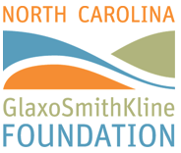
About the North Carolina GlaxoSmithKline Foundation:
The North Carolina GlaxoSmithKline Foundation is an independent self-funding 501(c)3 nonprofit organization supporting activities that help meet the educational and health needs of today's society and future generations. Since its creation in 1986, the foundation has granted $68.9 million to support North Carolina projects and programs that emphasize the understanding and application of science, health and education at all academic and professional levels. Visit us at NCGSKFoundation.org.

About Arts For Life:
Arts For Life is a nonprofit organization dedicated to supporting people with serious illnesses and disabilities. By providing educational art programs, the organization enriches patients’ lives, nurtures their minds and spirits, and encourages positive healthcare experiences for children and their families. More information is available at www.artsforlifenc.org

